Best Practices: Internationalized Schema and JavaScript Functions

November 24, 1999

Internationalized Schema

One way to localize content is to create related attributes tables for each content type. The localized content is in the related attribute table. The rows of the related attribute table are the languages, the columns are the localized attributes.

This schema sample is from the default BroadVision shipped with One-To-One Enterprise V4.1.

BroadVision .src File

/* following is a multi value list for language translation of
some of the product columns. All attributes listed from
here onwards are under this translation table, until end of
file or another LIST_TABLE is encountered */

LIST_TABLE: BV_PROD_TRANSLATE "Translated Properties"

ATTRIBUTE: LANGUAGE
TYPE: STRING NOT_NULL
ATTR_KIND: KEY
COLUMN: varchar(40)
FRIENDLY_NAME: Language
SEMANTICS: Translation Language

ATTRIBUTE: NAME_TRANSLATE
TYPE: STRING
COLUMN: varchar(128)
FRIENDLY_NAME: Product Name
SEMANTICS: Translated Product Name

ATTRIBUTE: SDESC_TRANSLATE
TYPE: STRING
COLUMN: varchar(80)
FRIENDLY_NAME: Short Description
SEMANTICS: Translated Short Description

ATTRIBUTE: LONGDESC_TRANSLATE
TYPE: TEXT
FRIENDLY_NAME: Long Description
SEMANTICS: Translated Long Description

The Main Content Table

select oid, prod_id, name, last_mod_time, dept from bv_product;

OID | PROD_ID | NAME | LAST_MOD_TIME | DEPT
8001 | one | The first product. | 12-NOV-99 | 100
8002 | two | The other product. | 11-NOV-99 | 100

Related Attributes Table
select oid, language, name_translate, sdesc_translate from bv_prod_translate where oid= 8001;

OID | LANGUAGE | NAME_TRANSLATE | SDESC_TRANSLATE
8001 | EN | The first product. | short description.
8001 | ES | El primer producto. | Corta descripción.
8001 | FR | Le premier produit. | Courte description.

The Command Center can be used to enter the test data shown above:

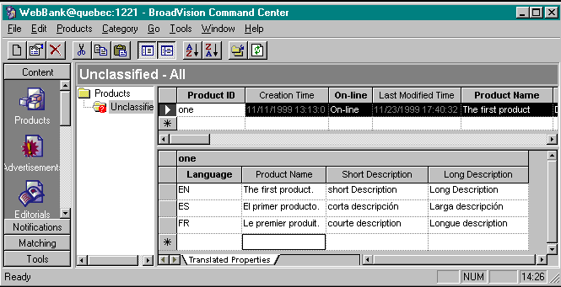

JavaScript Functions

Server-side JavaScript wrapper functions are used to find the translated row in the related attributes table. The function takes a content item, language, and an attribute name in, searches the translation table for the localized attribute, and returns the localized attribute value. If there is no row for the selected language, the English row is returned. The BroadVision-related attribute methods are able to find the row. No SQL is necessary here. Use the BroadVision APIs. Example:

Static HTML Form

<html>
<body>

<form action=/cgi-bin/pdemers/translate.jsp>

language: <input type=text name=language value = "EN"><br>
attribute: <input type=text name=attribute value = "NAME_TRANSLATE"><br>

<input type=submit value="Go">
<input type=reset value="Clear">

</form>
</body>
</html>

JavaScript Page That Translates, Including Function
<html>
<body>

<%

//////////////////////////////////////
// Define the translation function.
// Note: This can be moved into a startup script or an include file.

var default_language = "EN";
var translation_table = "BV_PROD_TRANSLATE";
var language_column = "LANGUAGE";

function translate_attribute(content, attribute, language)
{
var translated_attributes;

translated_attributes = content.multiValueRow(translation_table, language_column, language);

if (translated_attributes == null)
{
// This language doesn't have a translation. Use default.
translated_attributes = content.multiValueRow(translation_table, language_column, default_language);
}
else if (translated_attributes == null)
{
// Still null. There is a schema problem.
// TODO: Better logging.
return(null);
}

return(translated_attributes.get(attribute));
};

// Done defining translation function.
//////////////////////////////////////

var language = Request.value("language");
var attribute = Request.value("attribute");

var okay = true;
if (isEmptyString(language) || isEmptyString(attribute))
{
okay = false;
Session.errorMessage = "You must specify both a language and an attribute";
}

if (okay == true)
{
var cm = new BVI_ContentManager;
var c = cm.contentByKey("one", "WebBank", "PRODUCT");

var translated_attribute = translate_attribute(c, attribute, language);

Response.write("language= " + language + "<br>");
Response.write("attribute= " + attribute + "<br>");

if (translated_attribute != null)
Response.write("translated_attribute= " + translated_attribute + "<br>");
else
{
okay = false;
Session.errorMessage = "error translating attribute. Perhaps this attribute isn't translated?";
}
}

if (okay == false)
{
Response.write("FAILED: " + Session.errorMessage + " " + Error.reason + "<br>");
};

%>

</body>
</html>

Currency

The same technique can be used to maintain multiple currencies in the same site. Currencies and languages are independent of country, so a single related attributes table will not work. Also, it’s impractical to convert currencies on the fly, because of rounding, and also because different counties have different customs for dealing with taxes, for example, in the United States, prices are usually quoted without state and local taxes, in France, prices are quoted with VAT included.

select oid, currency, from bv_currency where oid= 8001;

OID | CURRENCY | PRICE
8001 | USD | 10.00
8001 | EUR | 11.00
8001 | HKD | 120.0

Note: This table is not included in the sample BroadVision schema.

